Group_4_ADAV_Model_final_v3 (1)

Behavioral Report

Author: Author

Revision: 0.2

|  |  |
| --- | --- |
| No Magic |  |
| One Allen Center, 700 Central Expressway South, Suite 110 Allen, Texas 75013 USA | Date: May 03, 2020 |

**Revision History**

|  |  |  |  |
| --- | --- | --- | --- |
| **Revision** | **Date** | **Reason For Changes** | **Author** |
| 0.1 | <date 1> | <draft> | <Author name> |
| 0.2 | <date 2> | <release> | <Author name> |
|  |  |  |  |

**Table of Contents**

Microsoft Word users please click here and press F9 to create Table of Contents.

OpenOffice.org users please remove this text and select Insert Table of Content from menu.

**Table of Figures**

Microsoft Word users please click here and press F9 to create Table of Contents.

OpenOffice.org users please remove this text and select Insert Table of Content from menu.

# Introduction

## Purpose

<This document provides an overview of behavioral view>

## Scope

<Provide a short description of the system being specified and its purpose, including relevant benefits, objectives, and goals>

## Overview

<Describe what the document contains and explain how document is organized>

# ADAV System::Behavioral Diagrams::Proposal Scenarios::Activity Diagrams

## ADAV Maintenance

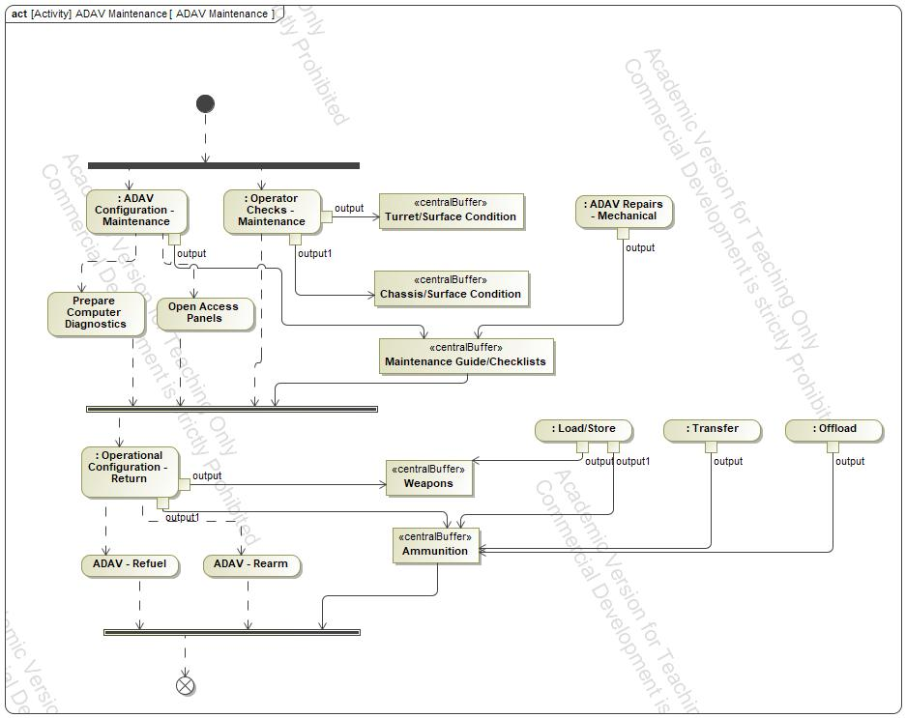

1. ADAV Maintenance

### ADAV - Rearm

### ADAV - Refuel

### Ammunition

### Chassis/Surface Condition

### Maintenance Guide/Checklists

### Open Access Panels

### output

### output

### output

### output

### output

### output

### output

### output1

### output1

### output1

### Prepare Computer Diagnostics

### Turret/Surface Condition

### Weapons

## Deploy ADAV on a C-17

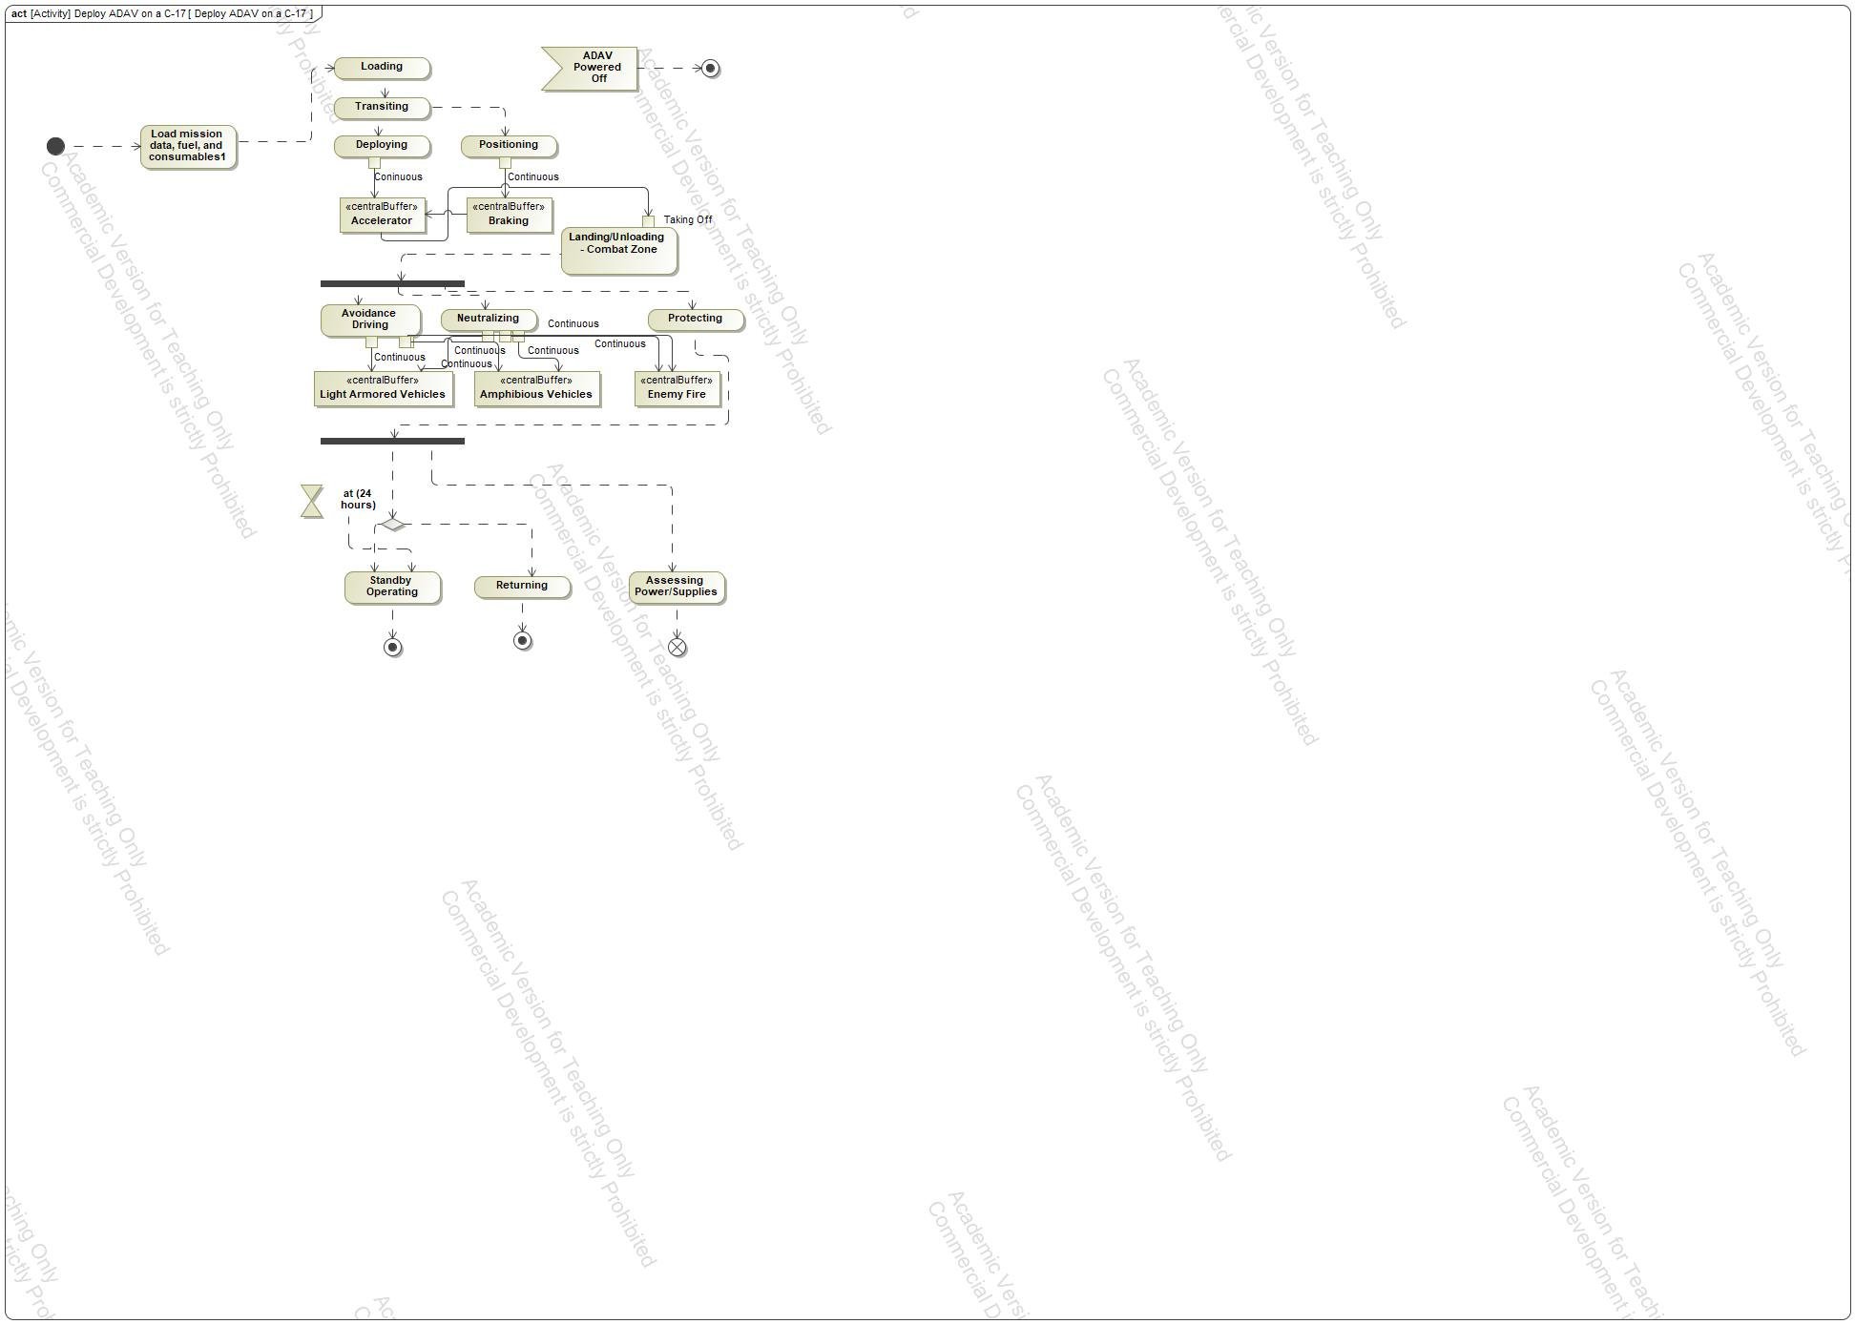

1. Deploy ADAV on a C-17

### Accelerator

### ADAV Powered Off

### Amphibious Vehicles

### Assessing Power/Supplies

### Avoidance Driving

### Braking

### Coninuous

### Continuous

### Continuous

### Continuous

### Continuous

### Continuous

### Continuous

### Deploying

### Enemy Fire

### Landing/Unloading - Combat Zone

### Light Armored Vehicles

### Load mission data, fuel, and consumables1

### Loading

### Neutralizing

### output

### Positioning

### Protecting

### Returning

### Standby Operating

### Taking Off

### Transiting

## Deploy ADAV on land using LCH

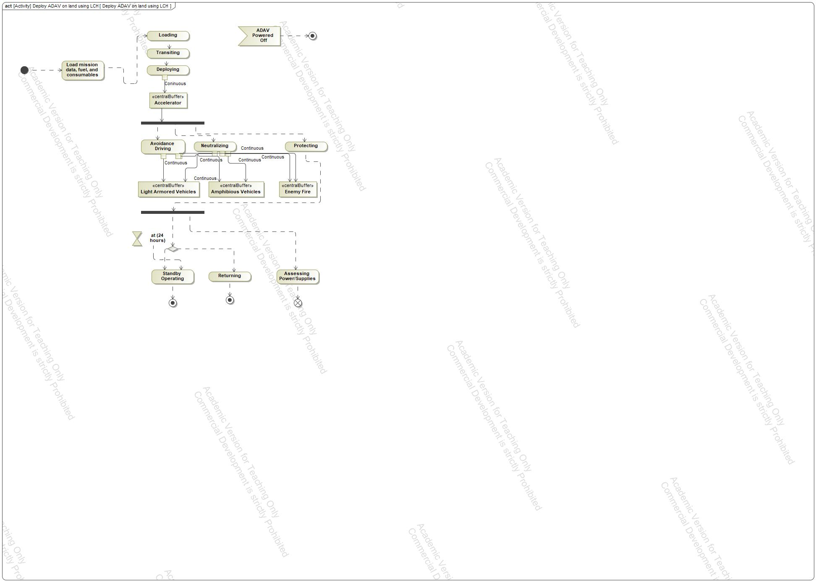

1. Deploy ADAV on land using LCH

### Accelerator

### ADAV Powered Off

### Amphibious Vehicles

### Assessing Power/Supplies

### Avoidance Driving

### Coninuous

### Continuous

### Continuous

### Continuous

### Continuous

### Continuous

### Deploying

### Enemy Fire

### Light Armored Vehicles

### Load mission data, fuel, and consumables

### Loading

### Neutralizing

### output

### Protecting

### Returning

### Standby Operating

### Transiting

# ADAV System::Behavioral Diagrams::Proposal Scenarios::State Machine Diagrams

## ADAV System

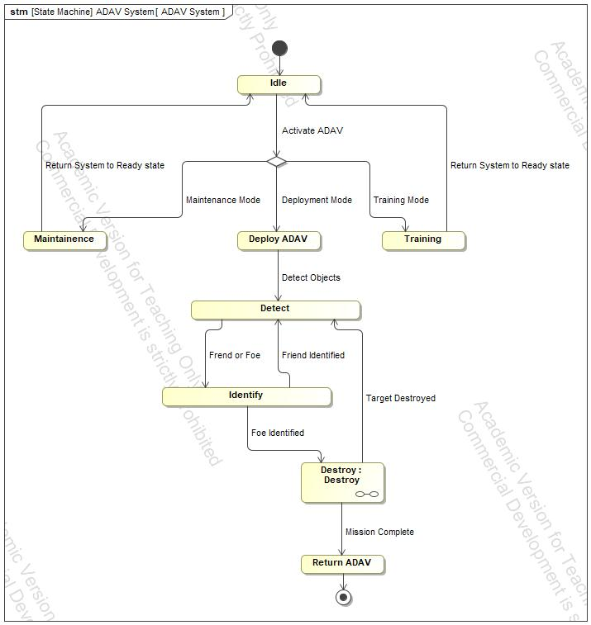

1. ADAV System

### Deploy ADAV

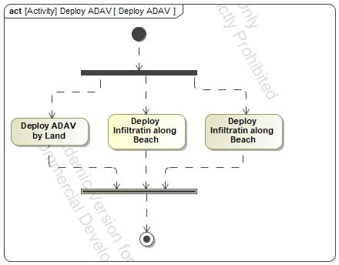

1. Deploy ADAV

Test 1

### Destroy

#### Destroy

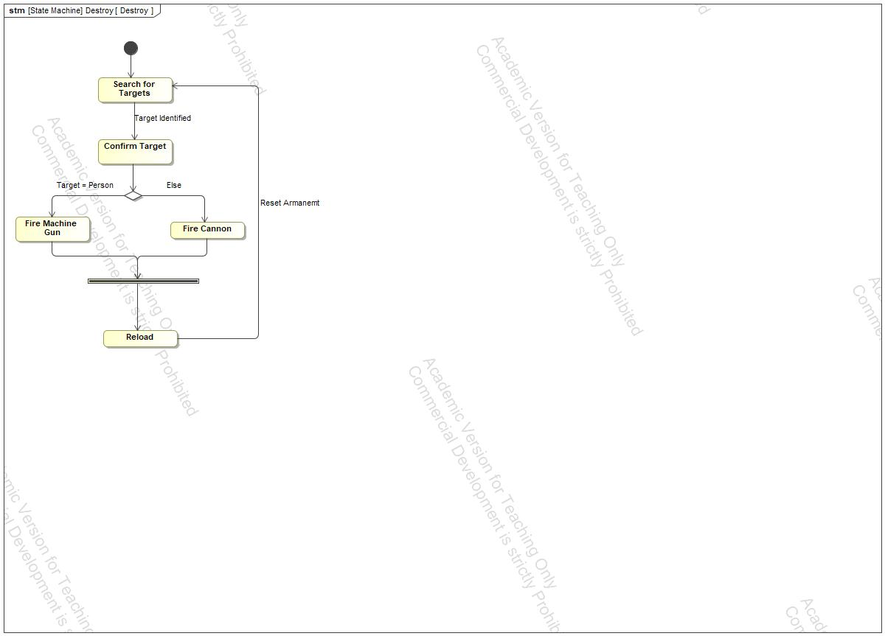

1. Destroy

##### Confirm Target

##### Fire Cannon

##### Fire Machine Gun

##### Reload

##### Search for Targets

### Detect

### Identify

### Idle

### Maintainence

### Return ADAV

### Training

## Climate Control

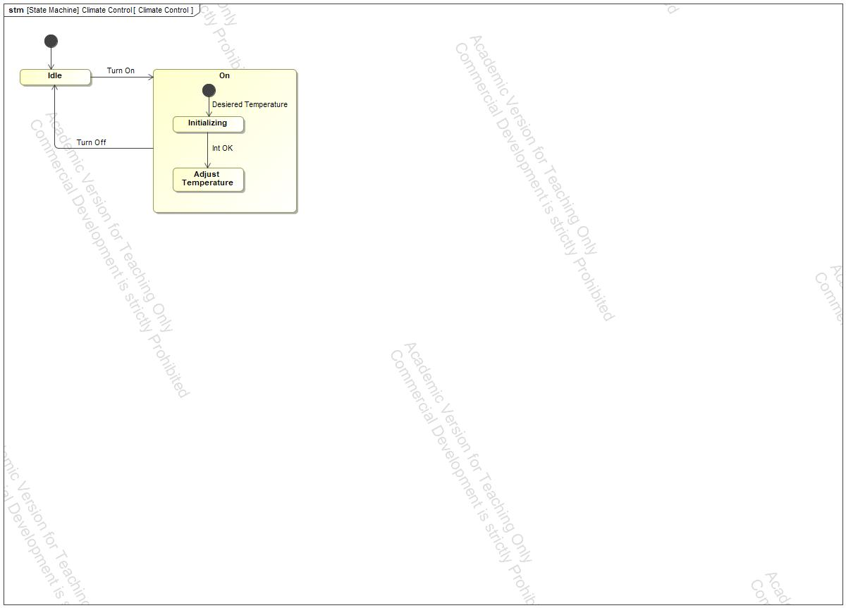

1. Climate Control

### Adjust Temperature

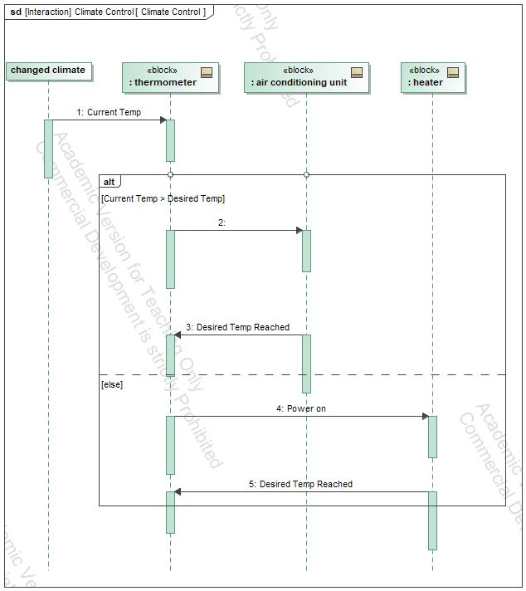

1. Climate Control

### Idle

### Initializing

### On

## Deployability

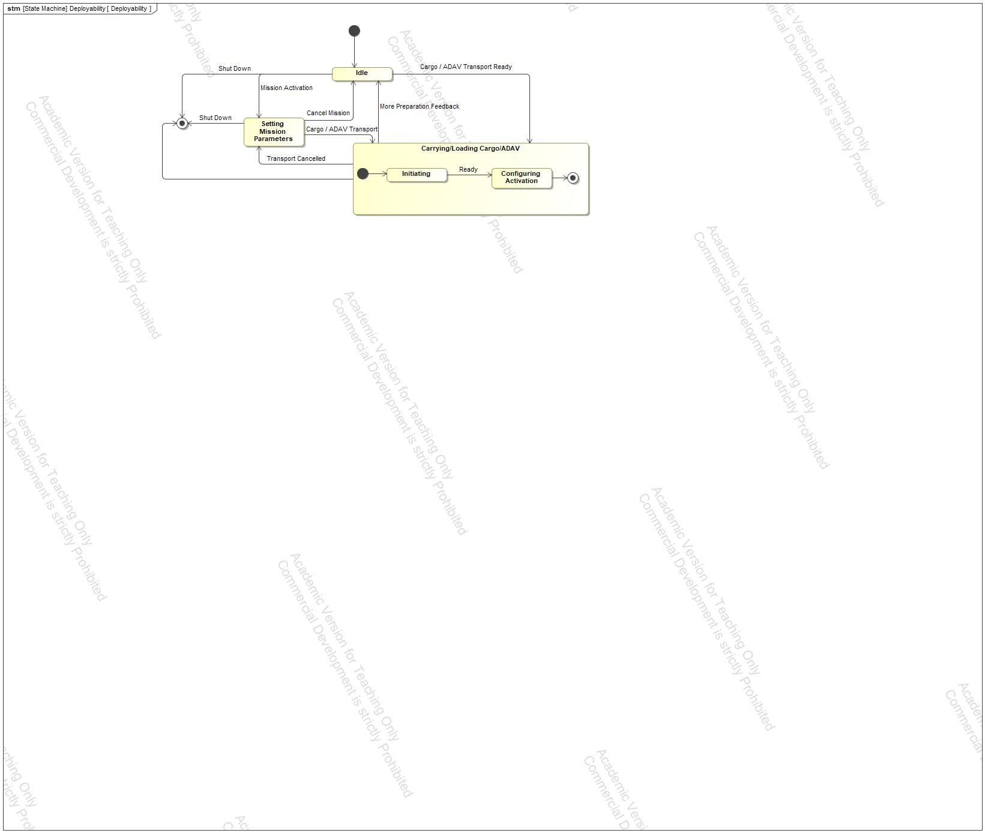

1. Deployability

### Carrying/Loading Cargo/ADAV

### Configuring Activation

### Idle

### Initiating

### Setting Mission Parameters

## Mobility

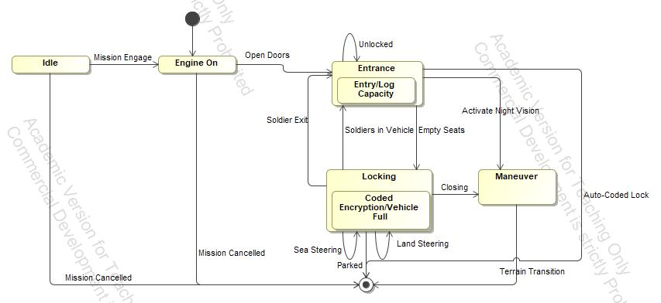

1. Mobility

### Coded Encryption/Vehicle Full

### Engine On

### Entrance

### Entry/Log Capacity

### Idle

### Locking

### Maneuver

## Security

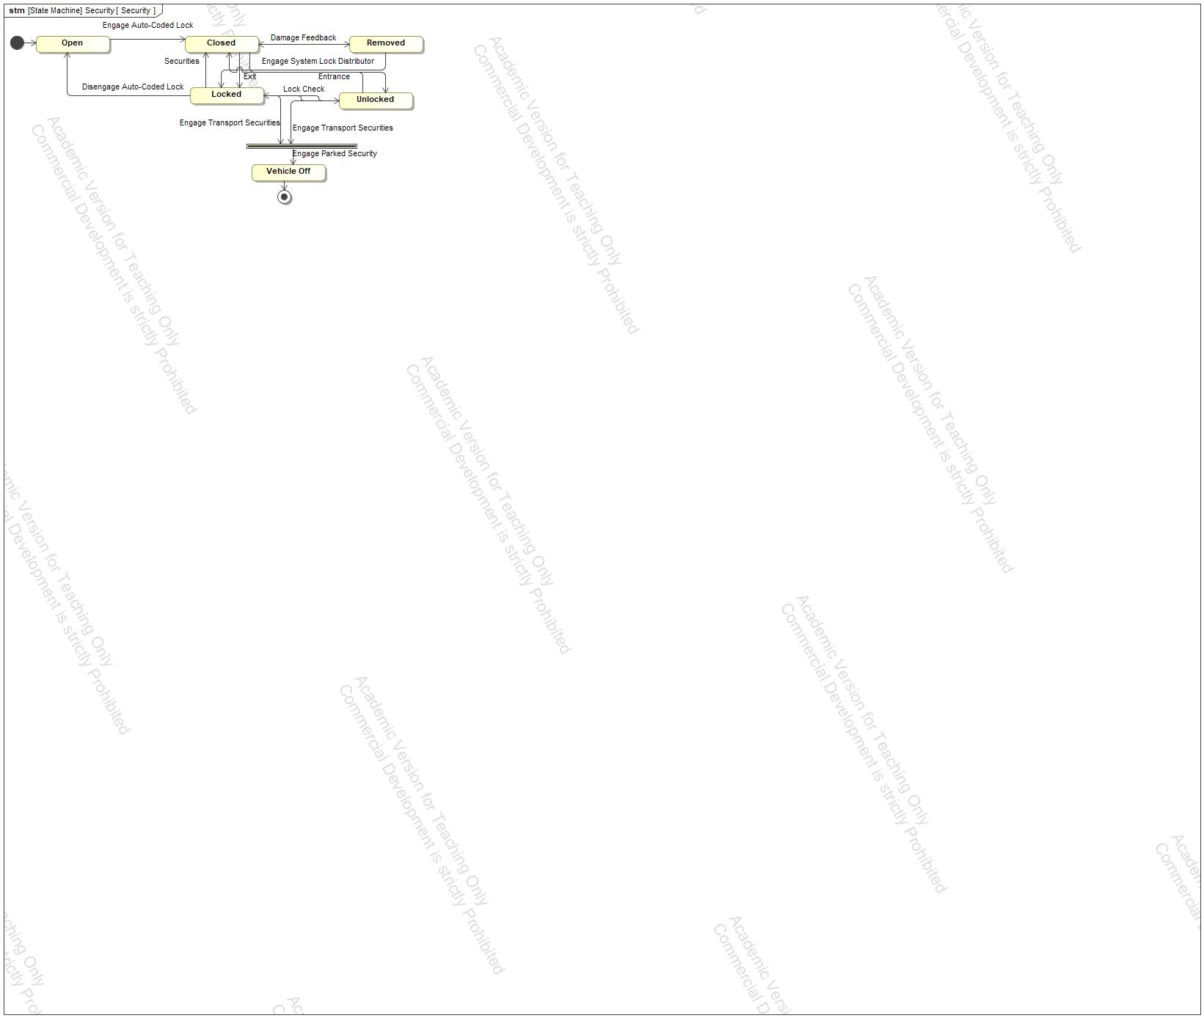

1. Security

### Closed

### Locked

### Open

### Removed

### Unlocked

### Vehicle Off

## Survivability

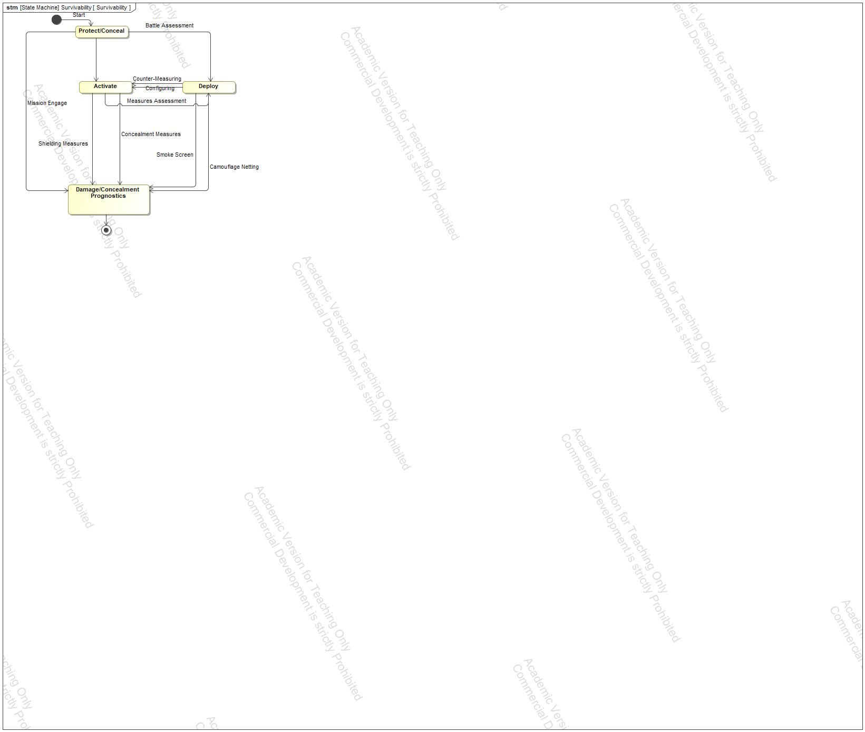

1. Survivability

### Activate

### Damage/Concealment Prognostics

### Deploy

### Protect/Conceal

## Deploy ADAV



1. Deploy ADAV

Test 1

### Deploy ADAV by Land

### Deploy Infiltratin along Beach